Incident Lifecycle Automation in ServiceNow

1. Project Overview
Incident Lifecycle Automation in ServiceNow is an end-to-end Incident Management implementation designed to manage incidents from creation to resolution.
The process includes Service and Service Offering creation, Incident Management, Incident Classification, Knowledge Integration, Reassignment and Escalation, Level 2 Support, Emergency Change Management, Child Incident Management, Incident Resolution, Knowledge Creation, and Final Validation.
The project demonstrates how different ServiceNow modules work together to provide an efficient and structured incident management process.

2. Project Objective
The objective of this project is to demonstrate a complete incident management lifecycle in ServiceNow.
The implementation enables support teams to:
- Create and classify incidents.
- Associate incidents with the correct Service, Service Offering, and Configuration Item.
- Use Knowledge articles for troubleshooting.
- Reassign incidents to appropriate support groups.
- Track incidents through Level 2 support.
- Handle emergency changes.
- Create and manage child incidents.
- Track SLAs.
- Resolve incidents with proper documentation.
- Create Knowledge articles from resolved incidents.
- Validate the complete incident lifecycle.

3. Service Hierarchy
The service hierarchy used in this project is:
Service → Service Offering → Configuration Item (CI)
The following Service and Service Offering are created:
- Service: Remote Access
- Service Offering: Corporate VPN
- Configuration Item: ThinkStationS20 / PowerEdge
This hierarchy allows incidents to be associated with the appropriate business service and technical configuration item.

4. Create New Service
If you have admin access, create the service.

Steps to Create New Service
- Go to All.
- Search for: cmdb_ci_service.LIST
- Click New.
- Enter the following details:
Field | Value
Name | Remote Access
Operational status | Operational
- Click Submit.

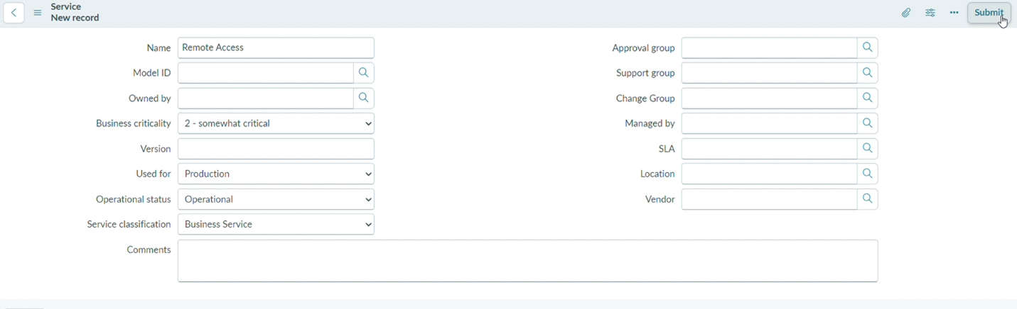

Expected Result
The Remote Access service is successfully created.

5. Create Service Offering
The Service Offering represents the specific service provided under the parent service.

Steps to Create Service Offering
- Go to All.
- Search for: service_offering.LIST
- Click New.
- Enter the following details:
Field | Value
Name | Corporate VPN
Parent | Remote Access
Operational status | Operational
- Click Submit.

Screenshot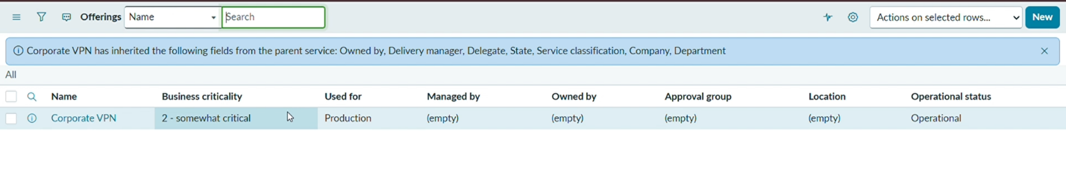

Expected Result
The Corporate VPN Service Offering is created under the Remote Access service.

6. Incident Creation
An incident record is created to log and track issues reported by users or detected within the IT environment.

Steps
- Open ServiceNow.
- Impersonate Beth Anglin.
- Navigate to:
Service Operations Workspace → List → Incidents → Open
- Click New.

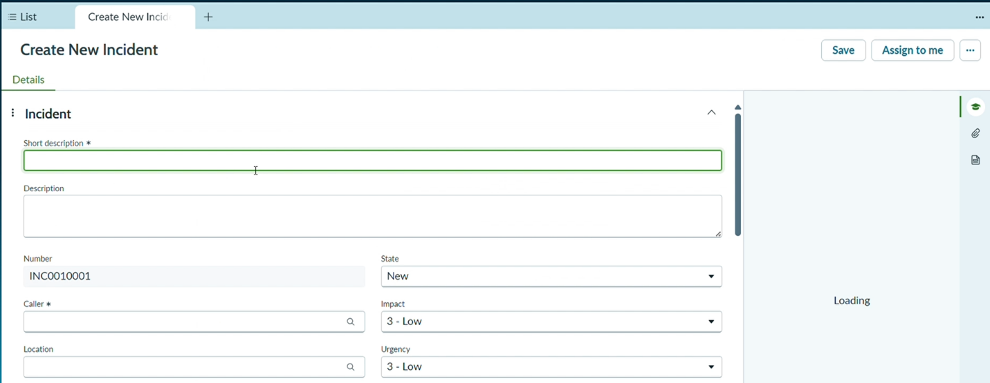Expected Result
A new incident record is created and is ready for classification and processing.

7. Incident Classification
Incident classification involves categorizing the incident based on its type, category, subcategory, impact, urgency, service, and related configuration items.

Steps
Stay in the same incident.
Go to the Details tab.
Update the following:
Field | Value
Description | Michael advised he was able to connect yesterday evening, but this morning received an authentication error. The Internet works fine.
Channel | Phone
Category | Network
Subcategory | VPN
Urgency | 2 - Medium
Service | Remote Access
Service Offering | Corporate VPN
Configuration Item | ThinkStationS20 (Any one)
In the Compose section:
Work notes: Classified and assigned incident.
Then:
- Click Assign to me.
- Click Save.

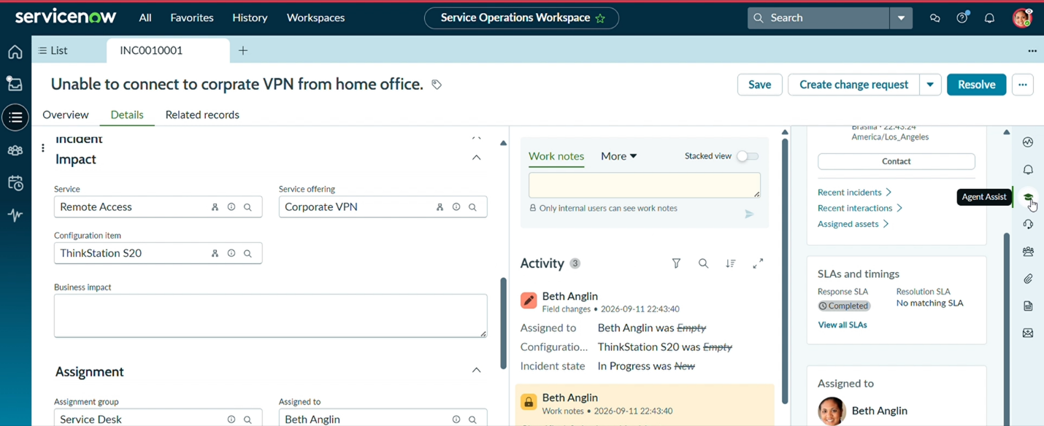Expected Result
The incident is properly classified and associated with the Remote Access service, Corporate VPN offering, and selected Configuration Item.

8. Knowledge Integration
Knowledge Integration connects the ServiceNow Knowledge Base with Incident Management.
It helps support teams access relevant troubleshooting information while working on an incident.

Steps
- Click Agent Assist on the right-side panel.
- Ensure Knowledge Articles are selected.
- Verify that Knowledge articles appear based on the short description.
- Open any one article.
- Click on the 3 dots.
- Select Mark Article as Helpful.
- Click Attach Article.
- Enter the comment:
Follow the Steps and Resolve the Incident.
- Select Attach Article.
- Return to the incident.

Verify
Verify the following:
- Knowledge article is linked in the Activity log.
- Helpful indicator is marked.
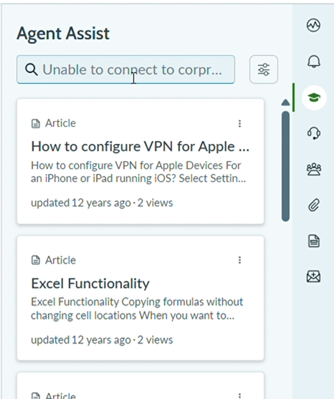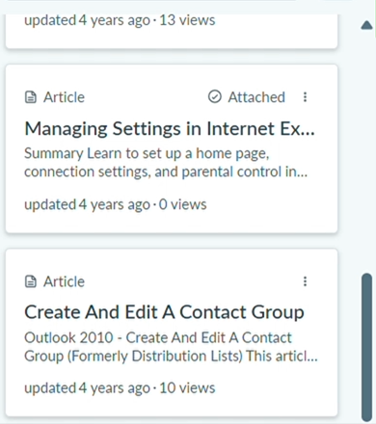

Expected Result
The relevant Knowledge article is successfully attached to the incident and can be used for troubleshooting.

9. Reassignment and Escalation
Reassignment and escalation ensure that incidents are routed to the appropriate support teams based on priority, complexity, and service requirements.

Steps
In the Details tab:
- Add Samantha Bordwell to the Watch list so she can track the incident and receive updates.
- Add Beth Anglin to the Work notes list so she can follow the work notes and stay updated on the incident resolution.
This allows the incident to be assigned to another team for further resolution and tracking while ensuring the required members can monitor the incident and its updates.
Note: If any of the mentioned members cannot be found, select another available member instead.

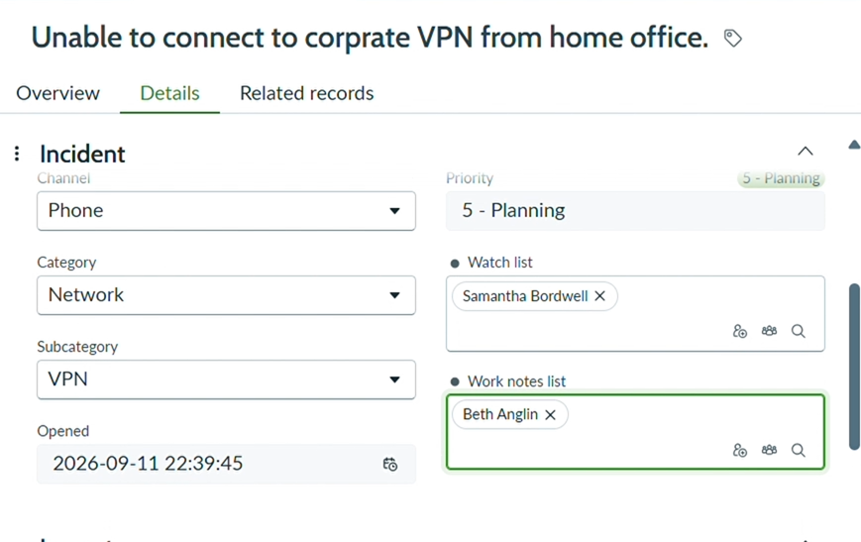Expected Result
The required users are added to the appropriate lists and can monitor the incident.

10. Assignment to Network Team
The incident is reassigned to the appropriate technical support team.

Steps
- Update Assignment group to:
Network
- Verify that the Assigned to field clears automatically.
- Click Save.

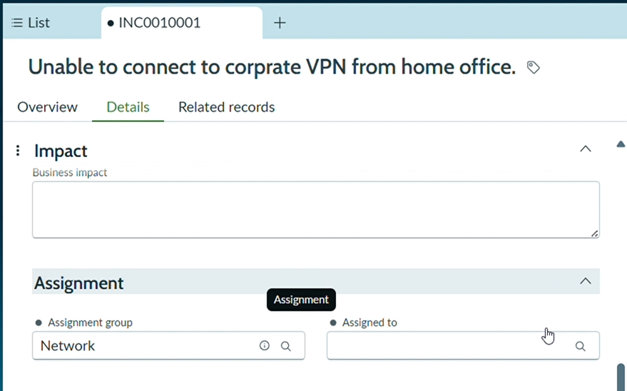Expected Result
The incident is assigned to the Network support group and the Assigned to field is cleared automatically.

11. Level 2 Support Incident Tracking
Level 2 support handles incidents that require advanced technical expertise.

Steps
- Impersonate David Loo.
- Select the 3 dots on the Banner.
- Select Workspaces.
- Navigate to:
Service Operations Workspace → Incidents → Open
- Open the VPN incident.
- Click Assign to me.

Verify
Verify:
- Description is visible.
- Knowledge articles are visible.
- SLA is visible in Task SLAs in the Related Records section.

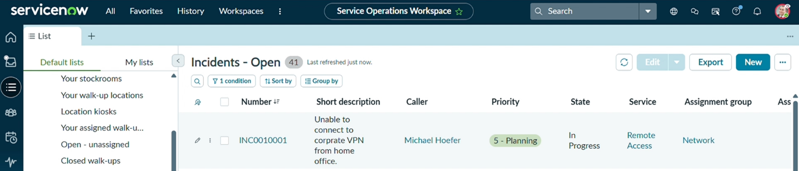Expected Result
Level 2 support can access the incident, Knowledge articles, and SLA information required for resolution.

12. Configuration Item Update and Incident Hold
The Configuration Item is updated and the incident is placed on hold while waiting for the required change.

Steps
- Update Configuration Item from ThinkStation to PowerEdge.
- Click Save.
- Return to the incident.
- Update:
Field | Value
State | On Hold
On Hold Reason | Awaiting Change
- Click Save.

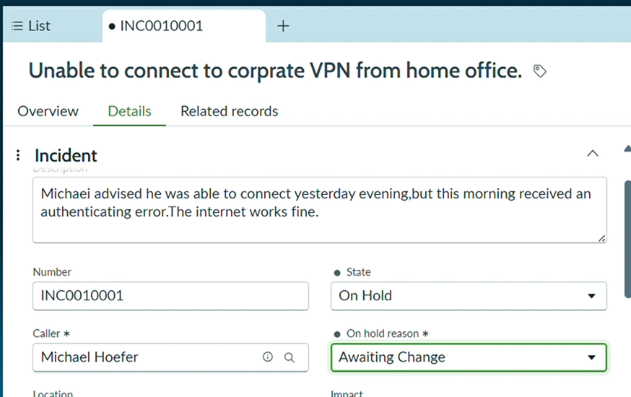Expected Result
The Configuration Item is updated to PowerEdge and the incident is placed in the On Hold – Awaiting Change state.

13. Child Incident Creation
Child Incident Creation is used when multiple users are affected by the same issue.
The child incident is linked to the parent incident for centralized tracking and management.

Steps
From the Related Records tab:
- Select Child Incidents → New.
- Enter the following:
Field | Value
Short Description | Unable to connect to Corporate VPN
Caller | Select any user
Description | User receiving VPN authentication failure error.
- Click Save.
- Make note of the incident number.
- Return to the Parent Incident → Related Records.

Verify
Verify that the child incident is listed under the parent incident.

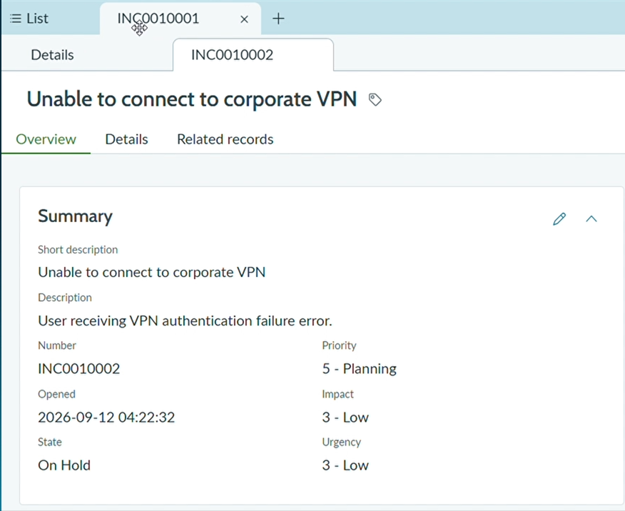Expected Result
The child incident is successfully created and linked to the parent incident.

14. Cause Identification
The probable cause of the incident is documented.

Steps
- Go to the Overview tab.
- Add Cause.
- Enter:
Probable Cause:
PowerEdge service was suspended and required restart.
- Click Save.

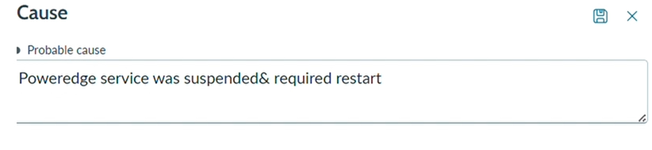Expected Result
The probable cause is recorded in the incident.

15. Emergency Change Request Creation
Emergency Change Request Creation is used when an urgent change is required to resolve a critical incident or prevent major service disruption.
The change process provides controlled handling of the emergency change while documenting the change and its relationship to the incident.

Expected Result
The emergency change is documented and associated with the incident resolution process.

16. Incident Resolution
Incident Resolution involves identifying the cause, applying the appropriate solution, documenting the resolution, and closing the incident.

Steps
Add the resolution details:
Field | Value
Resolution Code | Workaround provided
Resolution Notes | Restarted VPN-SRV-02 service as per emergency change request.
- Save the resolution.
- Click Resolve.
- Confirm the popup by selecting Resolve.
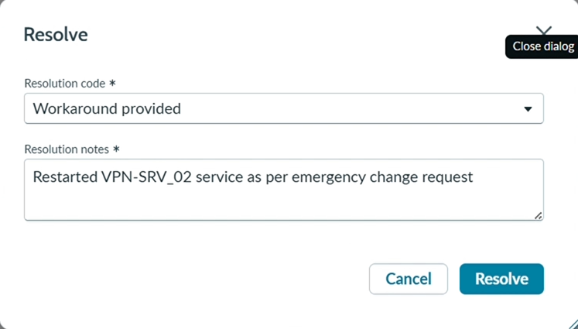

Expected Result
The incident is successfully moved to the Resolved state with the resolution information documented.

17. Knowledge Creation
Knowledge Creation involves developing a Knowledge article from a resolved incident.
This allows the documented solution to be reused for similar incidents in the future.

Steps
- Click Create Knowledge.
- Select IT as the Knowledge Base.
- Select article Template as Standard.
- Click Next.
- Verify all the details.
- Click Save.
- Go back to the Parent Record.
- Open Related Records.
- Verify the created Knowledge article.

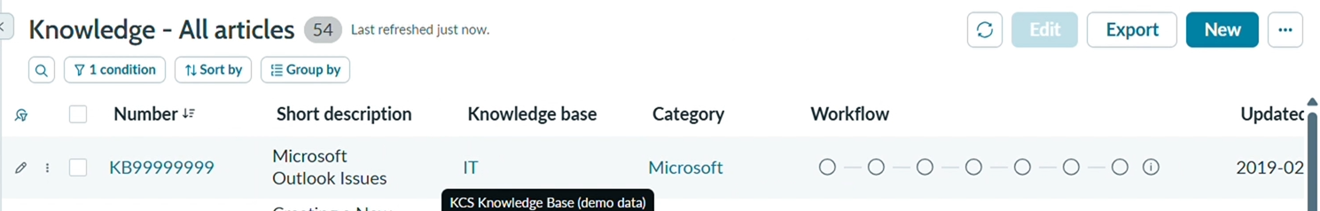Expected Result
A Knowledge article is successfully created from the incident resolution and is available in the related records.

18. Final Validation
The complete incident management process is validated to ensure that all related records and lifecycle activities have been completed successfully.

Verify
- Parent incident state = Resolved
- Child incident state = Resolved
- Activity shows resolution triggered by parent
- Change request linked
- Knowledge article created
- SLA tracking visible

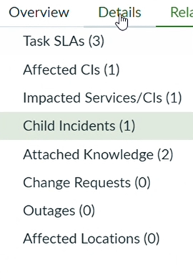Expected Result
All major components of the incident lifecycle are successfully completed and connected.

19. Testing and Deployment Validation
This scenario validates the complete Incident Management process.
The following areas are validated:

Incident Lifecycle
Verify that the incident progresses through the required stages from creation to resolution.

Escalation Process
Verify that the incident can be reassigned to the appropriate support group.

Change Integration
Verify that the emergency change is linked to the incident and referenced during resolution.

Knowledge Creation
Verify that a Knowledge article can be created from the resolved incident.

Child Incident Management
Verify that child incidents can be created and associated with the parent incident.

SLA Tracking
Verify that SLA information is visible and can be monitored during incident processing.

Multi-Team Collaboration
Verify that different support users and teams can monitor, update, and resolve the incident.

20. Project Outcome
This project demonstrates a complete Incident Management lifecycle automation in ServiceNow.
Service Desk agents can log and classify incidents, leverage Knowledge for faster resolution, escalate incidents to Level 2 teams, initiate emergency changes, create child incidents, track SLAs, and document final resolution properly.
The integration between Incident, Change, and Knowledge modules ensures structured issue management, improved SLA adherence, centralized tracking, and better IT service delivery.

21. End-to-End Process Flow
Service Creation
↓
Service Offering Creation
↓
Incident Creation
↓
Incident Classification
↓
Knowledge Integration
↓
Reassignment to Network Team
↓
Level 2 Support
↓
Configuration Item Update
↓
Incident On Hold – Awaiting Change
↓
Child Incident Creation
↓
Cause Identification
↓
Emergency Change
↓
Incident Resolution
↓
Knowledge Creation
↓
Final Validation
↓
Testing & Deployment Validation

22. Conclusion
The Incident Lifecycle Automation project provides a structured approach to managing IT incidents in ServiceNow.
By connecting Incident Management, Service Management, Configuration Management, Change Management, Knowledge Management, and SLA tracking, the solution improves incident handling, supports faster resolution, enables effective escalation, and ensures that important incident information is properly documented.
The completed workflow demonstrates how ServiceNow can be used to manage incidents from initial reporting through final resolution and knowledge reuse.

